OOP Lab

PACMAN GAME – JAVA PROJECT REPORT
Submitted by:
2025_CYS_170 (Tahir Noor)
Cyber Security SECTION (C)
Submitted to:
Prof.Muhammad Mubashar
Department of Computer Engineering
University of Engineering and Technology, Lahore

1. Introduction:
This project is a simple console-based Pacman game developed in Java. It includes a player (Pacman), a ghost enemy, and food items placed on a grid.

2. Objectives:
*Understand Object-Oriented Programming (OOP) *Implement classes and objects *Use arrays and loops *Handle user input * Build simple game logic
3. System Design:
The program consists of five main classes: 1.PacmanGame 2.GameBoard 3.Pacman 4.Ghost 5. Food.

4. Code Explanation:

1. PacmanGame Class:
This is the main class that:
1.controls the game loop 2.handles user input 3.updates game state 4.checks for collisions.
public class PacmanGame {
public static void main(String[] args) {
GameBoard board = new GameBoard(10, 20);
Pacman pacman = new Pacman(1, 1);
Ghost ghost = new Ghost(8, 18);
Scanner sc = new Scanner(System.in);
boolean gameRunning = true;
while (gameRunning) {
board.display(pacman, ghost);
System.out.println("Score " + pacman.getScore());
System.out.print("Move (W/A/S/D): ");
char move = sc.next().toLowerCase().charAt(0);
pacman.move(move, board);
if (board.hasFood(pacman.getX(), pacman.getY())) {
pacman.eatFood();
board.removeFood(pacman.getX(), pacman.getY());
}
ghost.randomMove(board);
if (pacman.getX() == ghost.getX() && pacman.getY() == ghost.getY()) {
System.out.println("GAME OVER YOU GOT CAUGHT");
gameRunning = false;
}
}
System.out.println("Final Score: " + pacman.getScore());
}
}

2 . GameBoard Class:
GameBoard Class: 1.Manages the game grid, 2.Manage walls, and food placement. 3.It also displays the board in the console.
class GameBoard {
private Food[][] foodGrid;
private boolean[][] walls;
private int rows, cols;
private int totalFood;
private int eatenFood;
public GameBoard(int rows, int cols) {
this.rows = rows;
this.cols = cols;
foodGrid = new Food[rows][cols];
walls = new boolean[rows][cols];
totalFood = 0;
eatenFood = 0;
initializeBoard();
}
private void initializeBoard() {
for (int i = 0; i < rows; i++) {
for (int j = 0; j < cols; j++) {
if ((i == 0) || (j == 0) || (i == rows - 1) || (j == cols - 1)) {
walls[i][j] = true;
} else {
foodGrid[i][j] = new Food(i, j);
totalFood++;
}
}
}
}
public void display(Pacman p, Ghost g) {
for (int i = 0; i < rows; i++) {
for (int j = 0; j < cols; j++) {
if (i == p.getX() && j == p.getY())
System.out.print("P");
else if (i == g.getX() && j == g.getY())
System.out.print("G");
else if (walls[i][j])
System.out.print('#');
else if (foodGrid[i][j] != null && !foodGrid[i][j].isEaten())
System.out.print(".");
else
System.out.print(" ");
}
System.out.println();
}
}
public boolean isWall(int x, int y) {
return walls[x][y];
}
public boolean hasFood(int x, int y) {
return foodGrid[x][y] != null && !foodGrid[x][y].isEaten();
}
public void removeFood(int x, int y) {
if (foodGrid[x][y] != null) {
foodGrid[x][y].eat();
eatenFood++;
}
}
public boolean allFoodEaten() {
return eatenFood >= totalFood;
}
public int getRows() { return rows; }
public int getCols() { return cols; }
}

3. Pacman Class:
1.Represents the player. 2.Handles movement and scoring.
class Pacman {
private int x, y;
private int score;
public Pacman(int x, int y) {
this.x = x;
this.y = y;
this.score = 0;}
public void move(char direction, GameBoard board) {
int newx = x;
int newy = y;
switch (direction) {
case 'w':
newx--;
break;
case 's':
newx++;
break;
case 'a':
newy--;
break;
case 'd':
newy++;
break;
}
if (!board.isWall(newx, newy)) {
x = newx;
y = newy;
}}
public void eatFood() {
score += 10;
}
public int getX() { return x; }
public int getY() { return y; }
public int getScore() { return score; }
}

4. Ghost Class: 1.Represents the enemy. 2. Moves randomly across the board.
class Ghost {
private int x, y;
private Random rand = new Random();
public Ghost(int x, int y) {
this.x = x;
this.y = y;
}
public void randomMove(GameBoard board) {
int newX = x;
int newY = y;
int direction = rand.nextInt(4);
switch(direction) {
case 0:
newX--;
break;
case 1:
newX++;
break;
case 2:
newY--;
break;
case 3:
newY++;
break;
}
if(!board.isWall(newX, newY)){
x = newX;
y = newY;
}
}
public int getX() { return x; }
public int getY() { return y; }
}

5. Food Class:
1.Represents food items. 2.Tracks whether food is eaten or not.
class Food {
int x, y;
boolean eaten;
Food(int x, int y) {
this.x = x;
this.y = y;
this.eaten = false;
}
void eat() {
eaten = true;
}
boolean isEaten() {
return eaten;
}
}

5. Game Flow:
1. Game starts
2. Board displays
3. Player moves
4. Food eaten
5. Ghost moves
6. Collision check
7. Game continues or ends
6. Features:
1. Console-based UI 2. Score tracking 3.Random ghost movement 4. Boundary walls 5. Food system
7. Limitations:
1. No levels 2. No graphical interface

8. Conclusion:
This project demonstrates basic Java programming and OOP concepts through a simple Pacman game.
9. OutPut:
This is the screenshot of output:
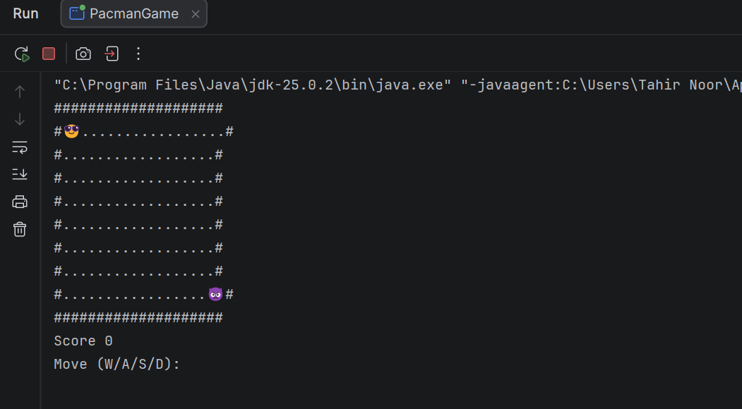
The game runs in the console and displays the board with Pacman, ghost, walls, and food.As:
1. The game displays a grid with Pacman (P), ghost (G), walls (#), and food (.)
2. Score increases as Pacman eats food

3. Player moves using W/A/S/D keys

W ______________ UP
A ______________ Left
S ______________ Down
D ______________ Right

4. Game ends when Pacman meets the ghost
Final Output:-
*GAME OVER YOU GOT CAUGHT
*Final Score displayed.

